USER INTERFACE DESIGN: EX 9
NAME: ABISHAA.R ROLL NO: 240701012
AIM:
The aim is to design a furniture shopping application interface that allows users to browse furniture items, view product details, add items to cart, and simulate a simple purchase flow using HTML, CSS, and JavaScript.
PROCEDURE:
Step 1: Setting Up the HTML Structure
Create the basic layout of the furniture shopping app using HTML.
Include:
- Navigation bar (Home, Categories, Cart)
- Product listing section
- Product cards (image, name, price, add to cart button)
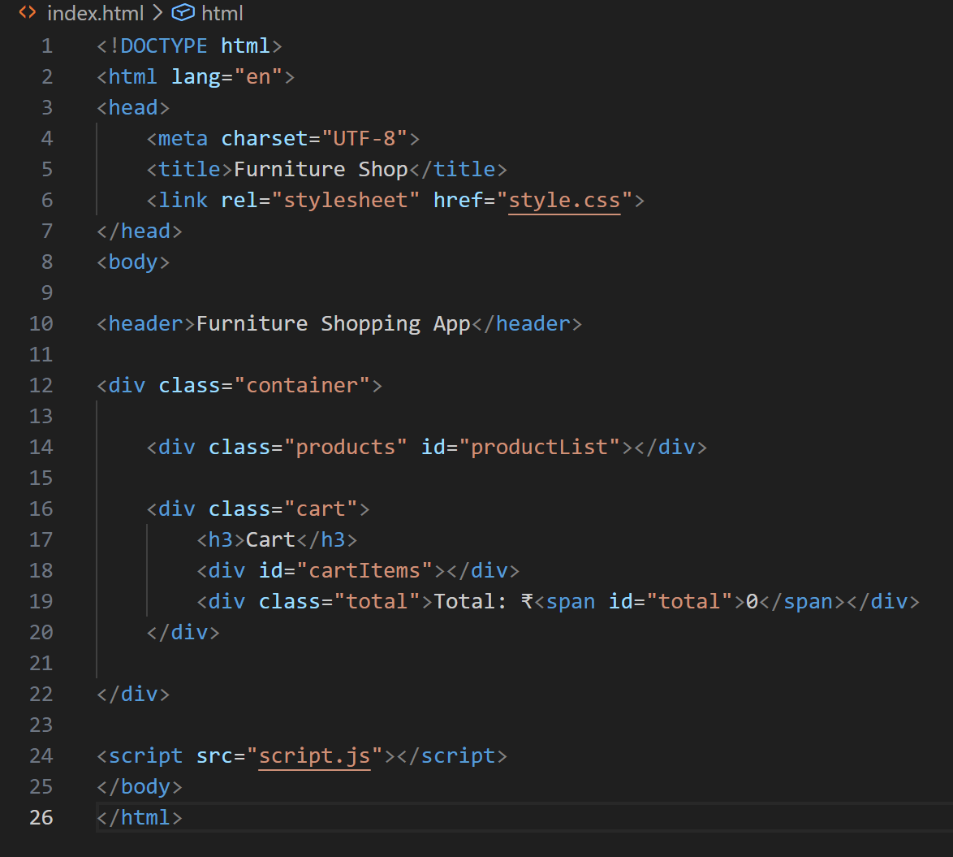

Step 2: Designing the UI with CSS
Style the application to make it modern and user-friendly:
- Use grid or flexbox for product layout
- Add attractive colors and spacing
- Design buttons and cards neatly
- Ensure responsiveness for different screen sizes
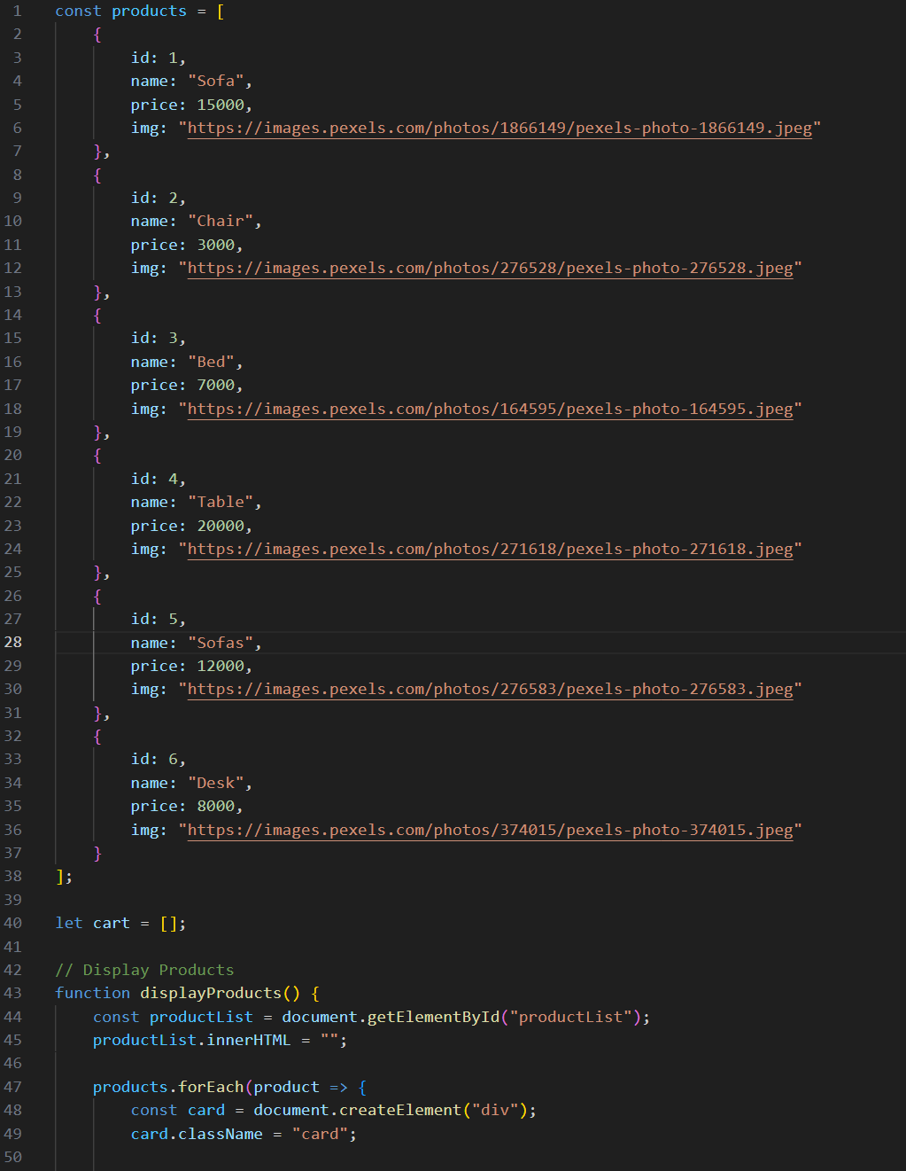
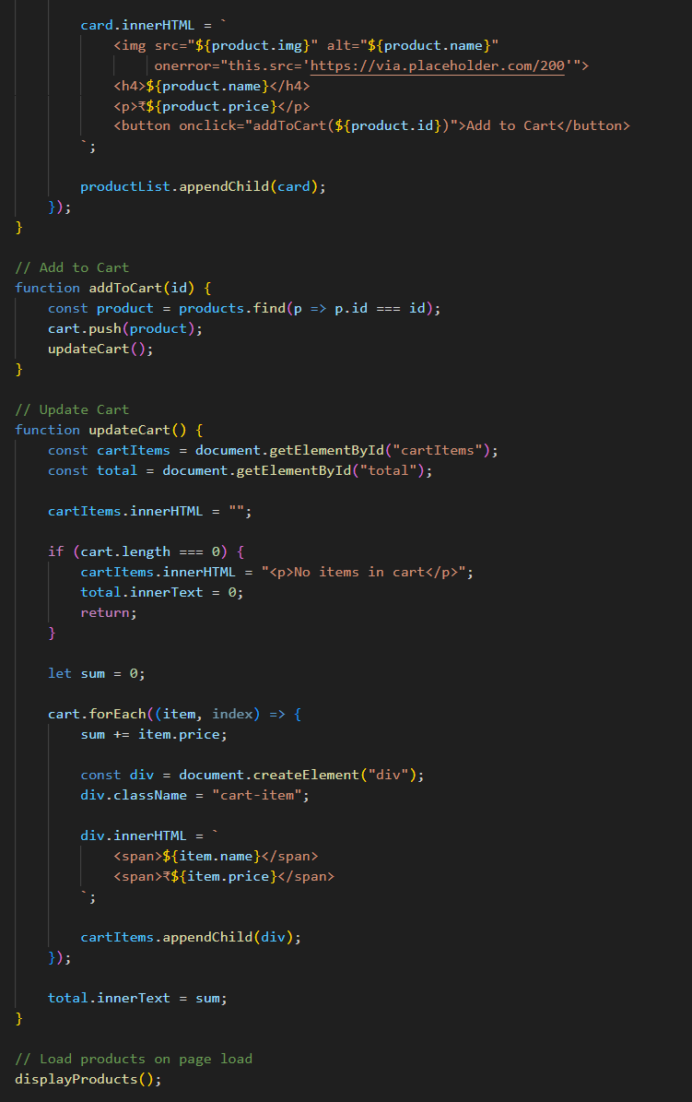

Step 3: Adding JavaScript Functionality
Implement basic interactivity:
- Add to Cart functionality
- Display selected items in cart
- Update total price dynamically
- Optional: Filter products by category
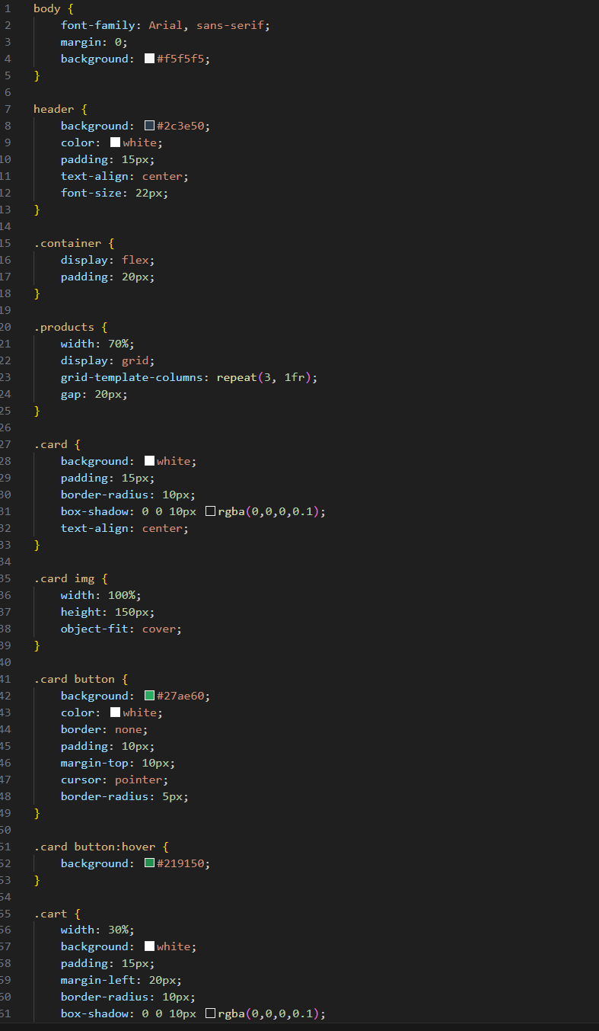
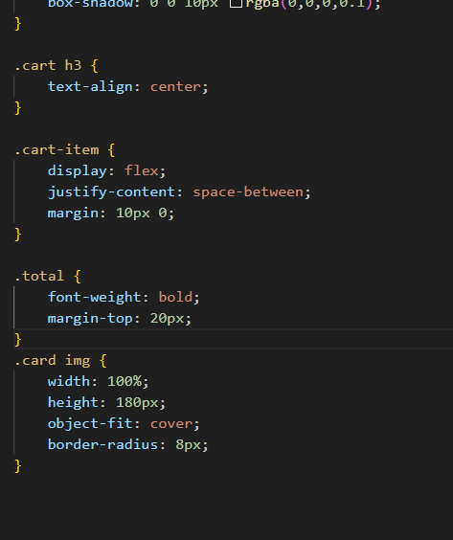

OUTPUT

For valid input:
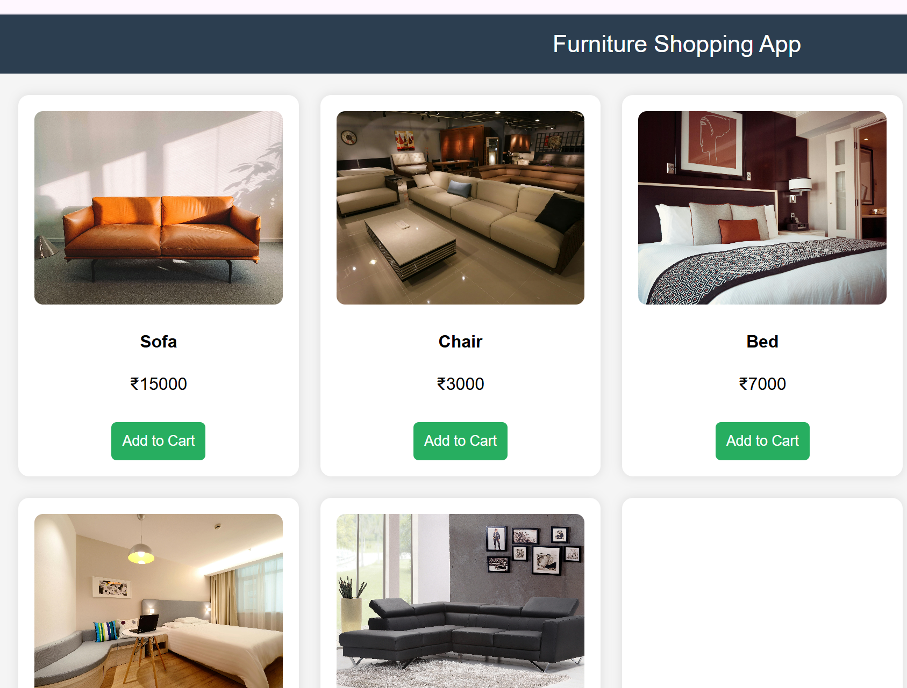
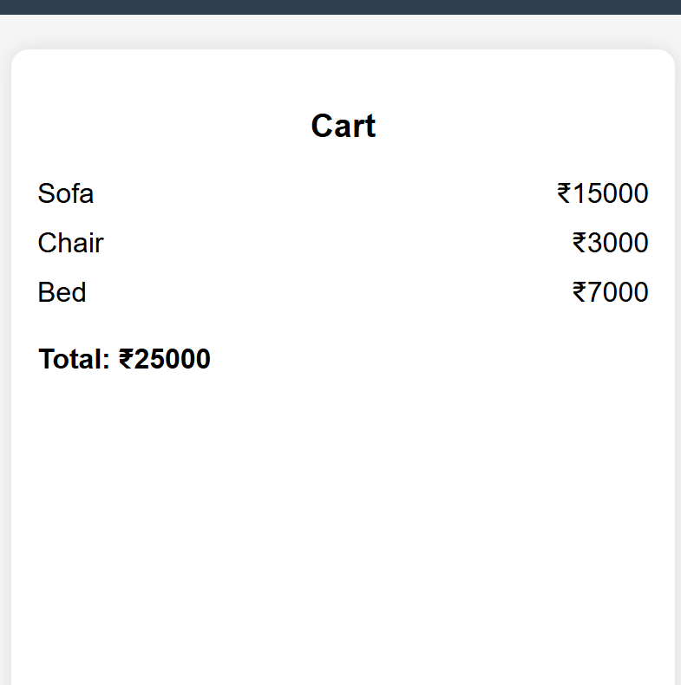

For invalid output:
